**Section 5**

**NVL FUNCTION**

select id,nvl(dept,'not assigned')

from singer;

**NVL DATE**

SELECT NVL(TO_CHAR(hiredate, 'YYYY-MM-DD'), 'no date')

FROM singer;

**CHARACTER TO DATE**

select to_date('may10,1989','fxmondd,yyyy') as "convert"

from dual;

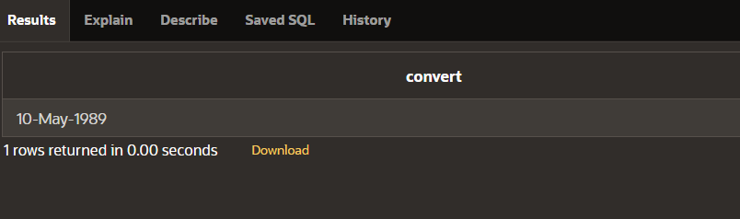

**NUMBER TO CHARACTER**

select to_char(salary,'$99,999')

from singer;

**DATE TO CHARACTER**

select to_char(hiredate,'month dd,yyyy')

from singer;

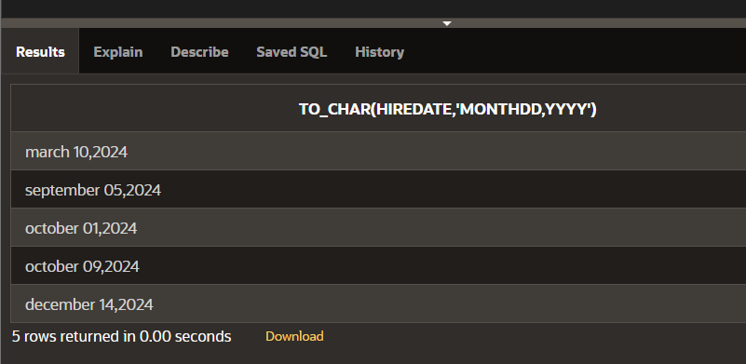

**DATE FUNCTION**

select id,name,hiredate,round(months_between(sysdate,hiredate)) as tenure, add_months(hiredate,6) as review, next_day(hiredate,'friday'),last_day(hiredate)

from singer;

